Assignment 3: Time-Series Weather Forecasting Using Deep Learning

1. Introduction
Time-series forecasting is a critical operation in most applications in the real-life like prediction of the weather, forecasting of finances and estimating energy demand. In contrast to conventional data, time-series data has temporal dependencies in which historical observations have an impact on the future. In this assignment, the deep learning models, i.e. Recurrent Neural Networks (RNNs), are used to predict weather data. The objective will be to test the various model structures and select the most effective model in terms of validation Mean Absolute Error (MAE).

2. Dataset Description
The data is the Jena Climate dataset, which comprises of historical weather records that are made at regular intervals. The data possesses several characteristics like temperature, humidity, pressure, and the speed of wind. The variable of interest that will be predicted is the temperature (C).
Preprocessing data involved the elimination of non-numeric data items, standardization of the data by means of standard scaling, and the generation of series of historical values to forecast the current ones. The data was divided into training (60%), validation (20%), and test (20) data. The dataset was downsampled and every 8th observation was chosen in order to decrease computational complexity.

3. Methodology
Two deep learning frameworks were put into practice and compared. The initial model is a GRU (Gated Recurrent Unit), and it is an effective recurrent network that is designed to learn temporal relationships. The second model is a hybrid 1D CNN + GRU model that is a combination of convolutional layers to extract local patterns and recurrent layers to learn sequences.
To make the models execute fast, a sequence length of 48 time steps, a batch size of 64, and 2 training epochs were used to train the models. The loss model was Mean Squared Error (MSE) and the performance of the models was measured in terms of Mean Absolute Error (MAE).

4. Results and Analysis
The models were tested on the basis of validation MAE. GRU model recorded a validation MAE of around 0.080 whereas CNN + GRU model recorded a validation MAE of around 0.099. These findings point to the fact that the GRU model achieved higher results.
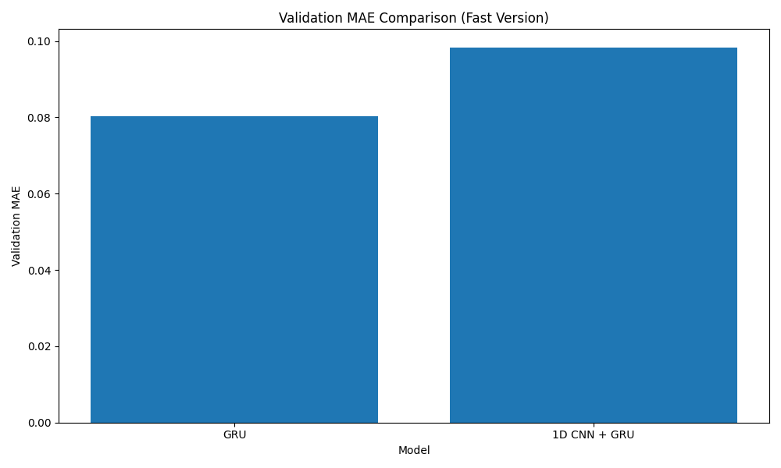
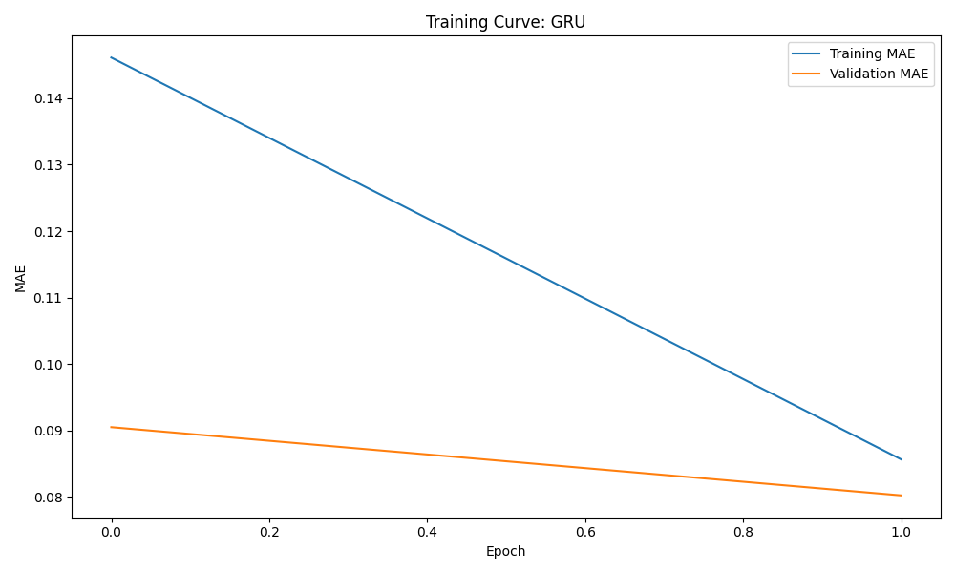
Based on the training curves, both of the training models improved throughout the training, although the GRU model had the lowest validation error. The CNN + GRU model did not achieve higher results when compared to the GRU model, probably because of the smaller dataset and the number of training epochs.

5. Best Model Selection
GRU model was chosen to be the most successful model because it had the lowest validation MAE. This means that the GRU model can be generalized to unseen data more than the hybrid one.

6. Discussion
The findings point to the fact that it is not necessarily true that the more complex the model, the better its performance will be. The more complex CNN +GRU model was worse than the simpler GRU model in this case. This could be explained by the lack of data, shorter training duration and the performance of GRU in terms of temporal dependencies.

7. Conclusion
Overall, this assignment illustrates how deep learning models can be applied to time-series predicting. GRU model showed the highest results and was able to be effective in this issue. The results indicate that the less complex models can do very well in conditions of constraint and show the significance of model selection and assessment.

